Software and Hardware Tools

Q1. Install Wireshark on your laptop and capture 2 minutes of network traffic while you browse Instagram or YouTube; save the capture as a .pcap file and note the top 3 protocols you see.
Ans:
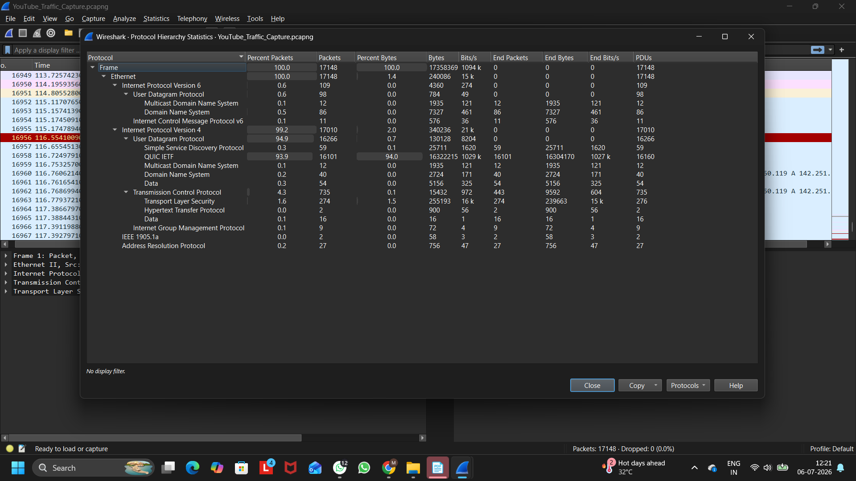
Figure 1: Wireshark Protocol Hierarchy Showing Top Network Protocols During YouTube Traffic Capture

Top 3 Protocols Observed:
Protocol | Purpose
QUIC IETF | Provides fast and efficient communication for YouTube video streaming.
UDP | Transfers streaming data quickly with low latency.
TLS | Encrypts data to ensure secure communication between the browser and YouTube servers.

Observation:
During the 2-minute Wireshark capture while browsing YouTube, the most common protocols observed were QUIC IETF, UDP, and TLS. QUIC and UDP were mainly used for fast video streaming, while TLS ensured that all communication was encrypted and secure.
Q2. Use the 'ping' command in Command Prompt or Terminal to test connectivity to www.spotify.com and www.zomato.com; record the response times and identify which site responds faster.
Ans:
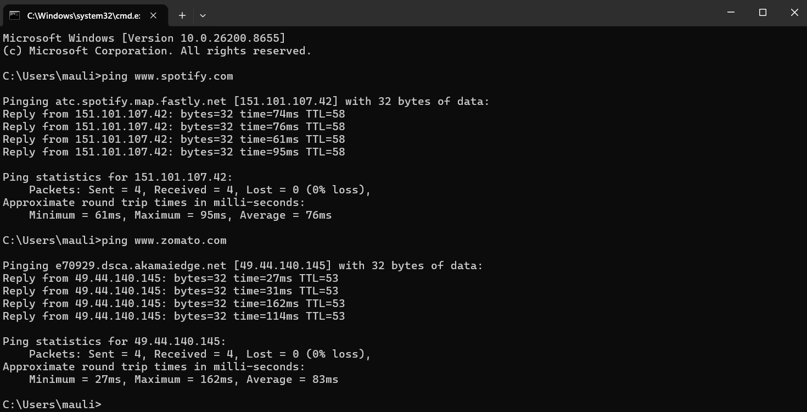
Figure 1: Ping Test Results for www.spotify.com and www.zomato.com
Website | Minimum Time | Maximum Time | Average Time
www.spotify.com | 61 ms | 95 ms | 76 ms
www.zomato.com | 27 ms | 162 ms | 83 ms

Based on the average response time, www.spotify.com was faster (76 ms) than www.zomato.com (83 ms).

Q3. Open Task Manager (Windows) or Activity Monitor (Mac) and list all running processes related to Chrome, WhatsApp Desktop, or any browser-based app you use; note the process name and memory usage for each.
Ans:
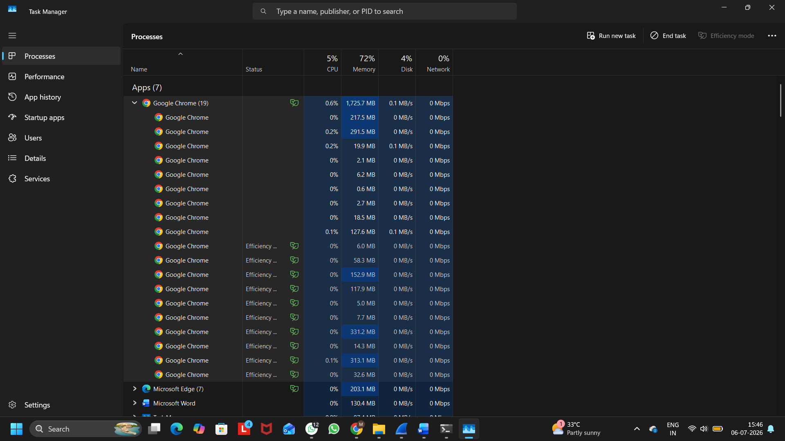
Figure 1: Google Chrome Processes in Windows Task Manager
Process Name | Memory Usage
Google Chrome (Main Process) | 1,725.7 MB
Google Chrome | 217.5 MB
Google Chrome | 291.5 MB
Google Chrome | 19.9 MB
Google Chrome | 2.1 MB
Google Chrome | 6.2 MB
Google Chrome | 0.6 MB
Google Chrome | 2.7 MB
Google Chrome | 18.5 MB
Google Chrome | 127.6 MB
Google Chrome | 58.3 MB
Google Chrome | 152.9 MB
Google Chrome | 117.9 MB
Google Chrome | 5.0 MB
Google Chrome | 7.7 MB
Google Chrome | 331.2 MB
Google Chrome | 14.3 MB
Google Chrome | 313.1 MB
Google Chrome | 32.6 MB

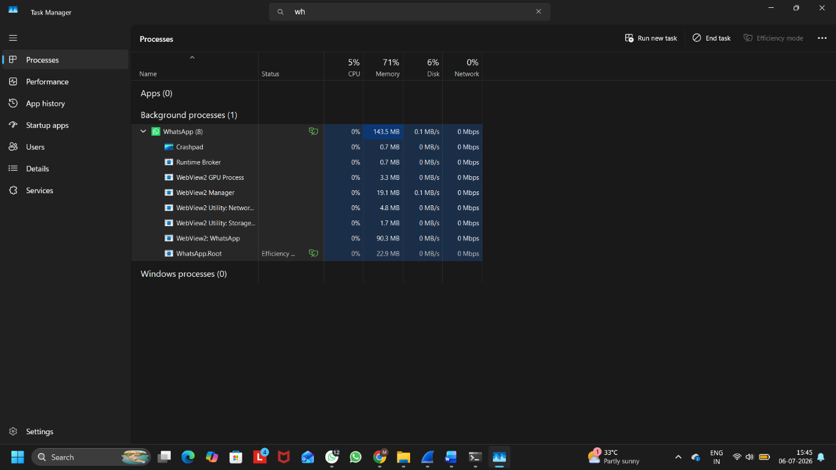
Figure 2: WhatsApp Desktop Processes in Windows Task Manager

Process Name | Memory Usage
WhatsApp (Main Process) | 143.5 MB
Crashpad | 0.7 MB
Runtime Broker | 0.7 MB
WebView2 GPU Process | 3.3 MB
WebView2 Manager | 19.1 MB
WebView2 Utility (Network) | 4.8 MB
WebView2 Utility (Storage) | 1.7 MB
WebView2: WhatsApp | 90.3 MB
WhatsApp.Root | 22.9 MB

Q4. Download and run the free version of 'Angry IP Scanner' or 'Advanced IP Scanner' to scan your local WiFi network; list the IP and device name of at least 2 devices connected to your network.<br><br><em><strong>Hint:</strong> Make sure your firewall allows scanning, and only scan your own home/college network.</em>
Ans:
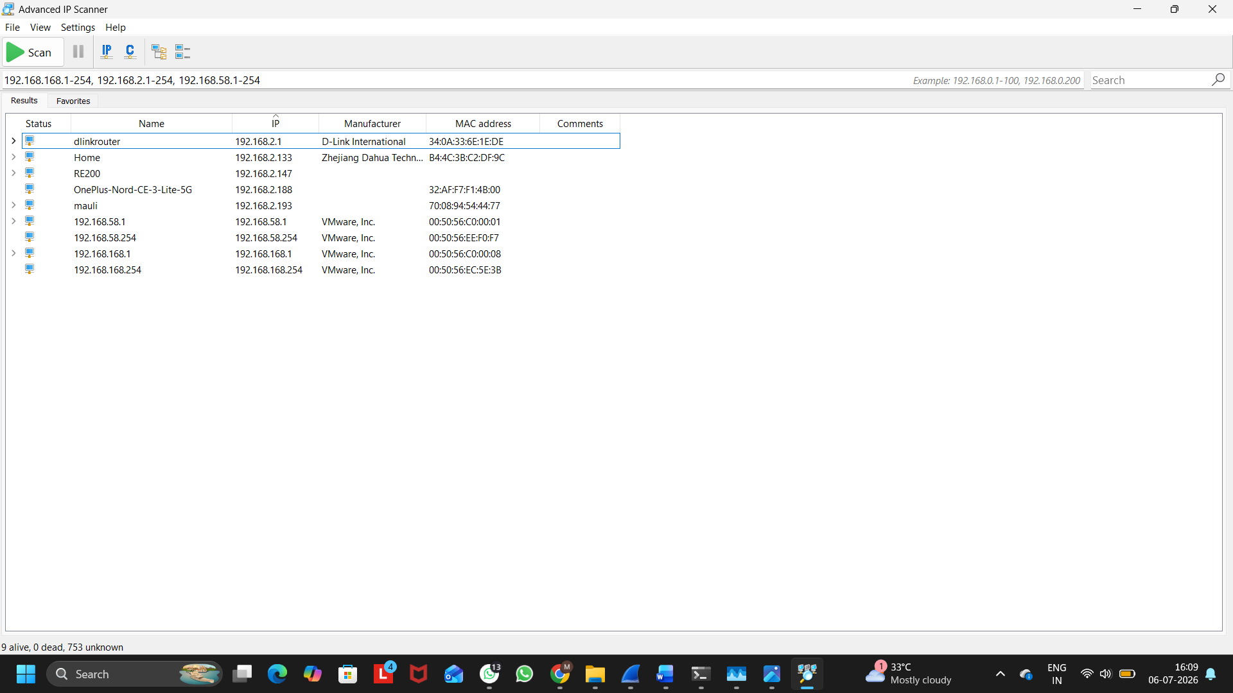

Figure 1: Network Scan Results Using Advanced IP Scanner

Device Name | IP Address
dlinkrouter | 192.168.2.1
Home | 192.168.2.133
OnePlus-Nord-CE-3-Lite-5G | 192.168.2.188
mauli | 192.168.2.193

Observation:
The local WiFi network was scanned using Advanced IP Scanner. The scan detected multiple connected devices, including the D-Link router, laptop, mobile phone, and other network devices. Each device was assigned a unique IP address, which helps identify and communicate with devices on the local network.

Q5. Use ChatGPT or Bing AI to suggest 3 hardware tools (like cable tester, crimping tool, or multimeter) used in network troubleshooting; for each, write one line describing when you would use it.

Ans:
Hardware Tool | When would you use it?
Cable Tester | To check whether a network (Ethernet) cable is working properly or has wiring faults.
Crimping Tool | To attach or replace an RJ45 connector on an Ethernet cable.
Multimeter | To test voltage, continuity, or power supply while troubleshooting networking devices.

